**user guide**

**Table of Contents**

1. Introduction
2. Using the System
3. Common Issues and Tips

**1.Introduction**

The Smart Traffic Light System is designed to provide advanced traffic management at an intersection using real-time data from various sensors and predictive models. The system includes a live dashboard that displays essential information such as traffic congestion, pedestrian count, weather conditions, and the status of each sensor and traffic light.

In addition to the dashboard, the system features a 3D simulation that visually demonstrates how vehicles and pedestrians move through the intersection, based on the current state of the traffic lights. This simulation helps users understand the system’s behavior in a clear and intuitive way.

This manual is intended for users who want to operate the system, view the live data, and follow the real-time behavior, without needing to interact with the code or have advanced technical knowledge. All explanations are written clearly and include visual examples for better understanding.

**2.Using the System**

After entering the system via the provided link, the main dashboard screen will load automatically.

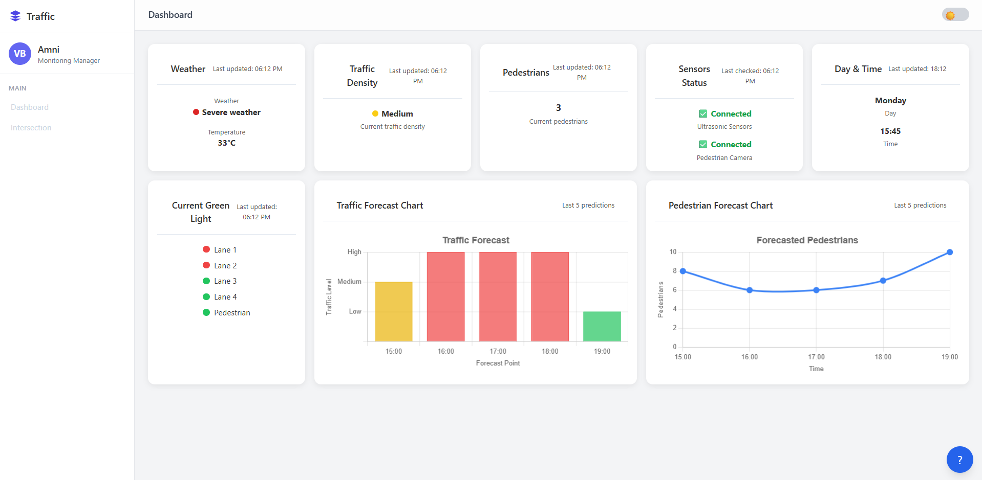

**Dashboard View**

The dashboard contains several cards, each updated live from the Firebase database.

**Weather:**

Shows the current weather condition, temperature, and alerts in case of severe weather.

Updates every 10 seconds.



**Traffic Density:**

Displays the current congestion level at the intersection (Low / Medium / High)

Updates every 10 seconds.



**Pedestrians:**

Shows the real-time number of pedestrians detected by the camera.

Updates every 10 seconds.



**Sensors Status:**

Indicates whether all sensors (ultrasonic + pedestrian camera) are connected and working properly.

Updates every 10 seconds.



**Day & Time**:

Displays the current day and time for context.

*Updates every 10 seconds.*



**Current Green Light:**

Highlights which traffic light is currently green (Lane 1–4 or Pedestrian).

Updates every 10 seconds.



**Traffic Forecast Chart:**

A color-coded bar chart displaying the next five predicted traffic levels.

The forecast values are provided by an internal prediction mechanism.

The chart updates automatically every hour.



**Pedestrian Forecast Chart:**

A line chart showing the expected number of pedestrians in the near future.

These values are also supplied by the system’s built-in forecasting component.

The chart updates automatically every hour.



**Intersection View:**

To switch to the simulation view, click the "Intersection" button in the sidebar.

This button is located on the left side of the screen under the MAIN section.



After clicking the "Intersection" button, a simulation screen will appear that represents the real-time behavior of the intersection.

The simulation is displayed in a 3D environment, and the user can scroll within the view to explore all road lanes, pedestrian movement, and traffic lights from different angles.

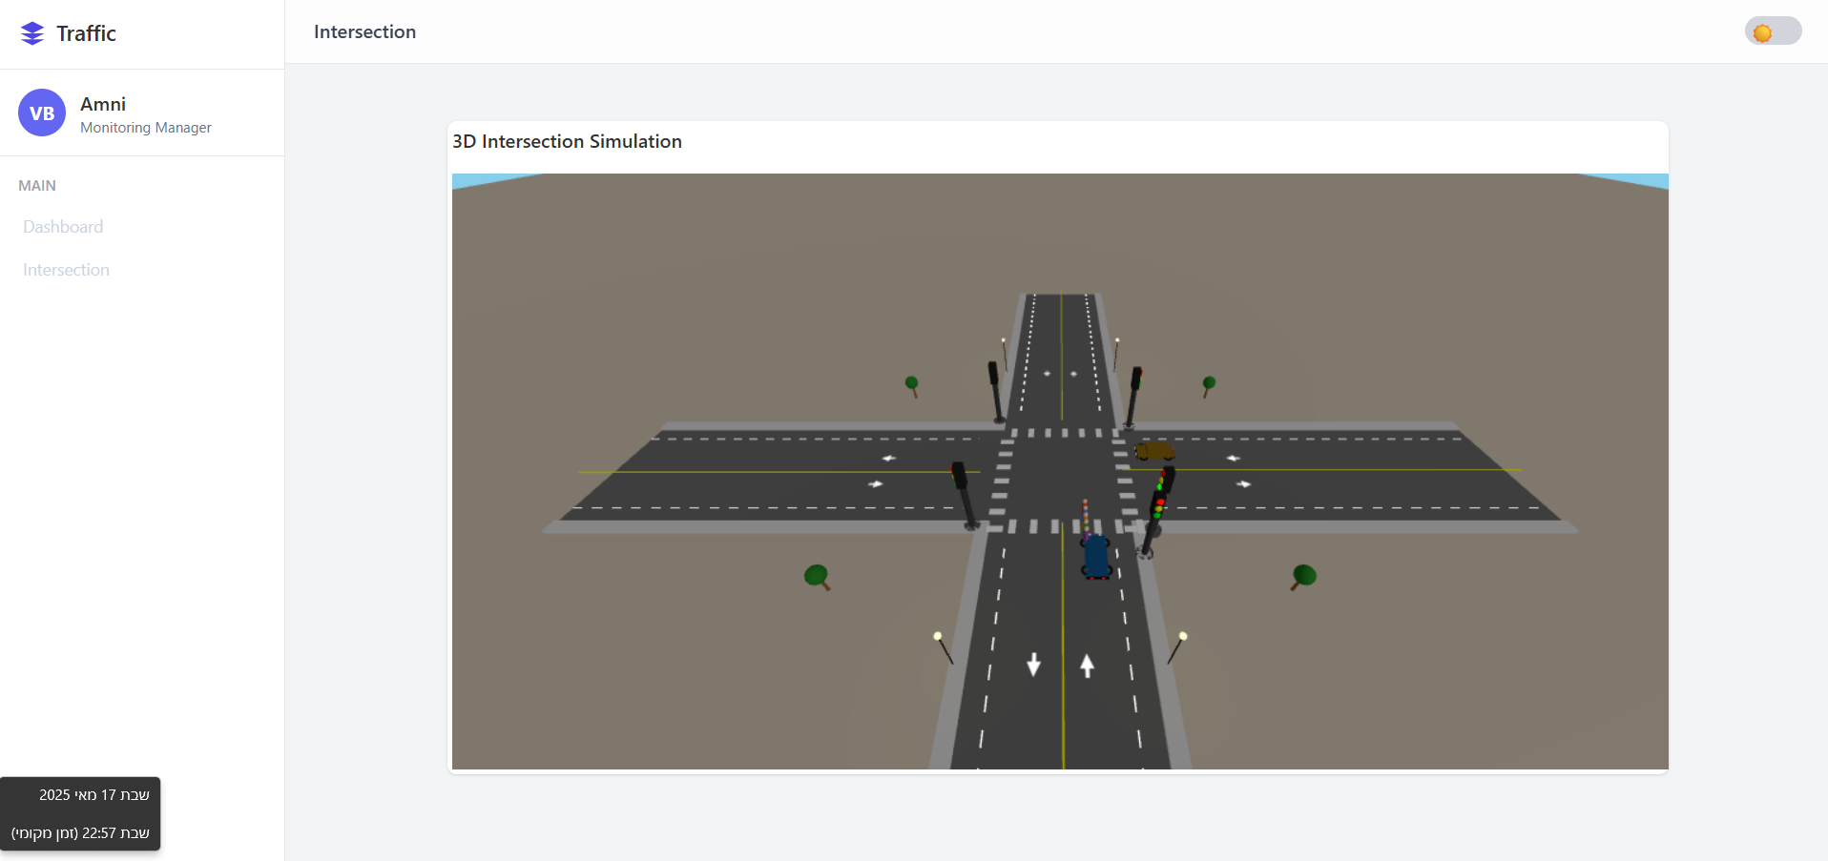

In the simulation view, you can observe how vehicles move through the intersection based on the current traffic light state, and how pedestrians cross the road only when the pedestrian light is green. The traffic lights are displayed as 3D poles with illuminated red or green lamps, depending on their real-time status. All movement in the simulation is updated live using data retrieved from the Firebase database, including traffic light status, pedestrian count, and vehicle presence at the intersection.

### **Help Button – Assistance Based on Your Current Screen**

To help you navigate the system easily, a help button (?) is located at the bottom-right corner of every screen.  
Clicking this button opens a help window with explanations tailored to the screen you're currently viewing.



For example:

* On the Dashboard, you'll see a breakdown of each card: weather, traffic congestion, pedestrian count, sensor status, and forecast charts, including how frequently each item updates.
* On the 3D Intersection View, you'll find explanations about vehicle movements, pedestrian crossings, and how real-time sensor data drives system behavior.

**3. Common Issues and Tips**

#### 1. The dashboard is blank / no data is showing

If the page loads but cards remain empty, check your internet connection. Refreshing the page usually resolves temporary issues with Firebase access.

#### 2. The simulation doesn’t load / screen stays gray

Make sure you're using a browser that supports WebGL, such as Chrome or Edge. A slow connection may also delay the loading. Try refreshing the page.

#### 3. Graphs are not updating

Both forecast charts update once per hour. If they appear empty, the forecast data may not be available yet or is still being processed.

#### 4. The system is slow or unresponsive

Since the system includes live data and 3D rendering, it is recommended to close unused tabs and ensure a stable internet connection. Older computers may struggle with the simulation.

#### 5. Recommended browser

Google Chrome is strongly recommended for best performance. Firefox may work, but older browsers may not fully support all features like the 3D view.